
InnoDevs SRS

DOCUMENT

2026

SOFTWARE REQUIREMENTS SPECIFICATION(SRS)

Contents
1.1 Introduction .................................................................................................................2
1.2 Problem Description .....................................................................................................3
1.3 Proposed Solution ........................................................................................................3
1.4 Functional Requirements ..............................................................................................3
1.5 Non-Functional requirements ........................................................................................4
3.1 User Authentication and Authorization ............................................................................5
3.2 Phrase Repository Management .....................................................................................5
3.3 Multi-Language Search (Core Feature) ............................................................................6
3.4 Translation Submission Workflow (Community Contribution) ............................................6
3.5 Favourites System ........................................................................................................8
3.6 Language Usage Statistics (Analytics) .............................................................................8
3.7 Student Profile..............................................................................................................9
3.8 Administrator Dashboard ..............................................................................................9
3.9 Data Seeding (Initial Setup) .......................................................................................... 10
4. Non-Functional Requirements ....................................................................................... 10
Use Case Descriptions ..................................................................................................... 11
Wireframes...................................................................................................................... 12

Team Members
Name | Surname
Lonwabo | Bhovula
Meluleki | Shandu
Siyabonga | Mkhize
Akhona | Maphumulo
Liyema | Zama
Scelokuhle | Shabalala

1.1 Introduction
The Purpose of the Multi-Language Phrasebook is to provide DUT students from different Linguistic-Backgrounds who are left at a disadvantage when it comes to Campus important resource information such as Registration, Accommodation, and Health Services because this information is mostly in English. The system aims to break down language barriers by allowing students to find translations for important campus-related information and contribute their own translations for review.

1.2 Problem Description
DUT is home to students from different linguistic backgrounds across KZN and beyond yet essential campus information covering registration, accommodation, health services and academic support is mainly conveyed in English, creating a significant language barrier for students who are more comfortable communicating in isiZulu, Sesotho, isiXhosa, or any of the other official South African languages. As a result, these students are placed at a disadvantage when trying to access and understand information that is critical to their day-to-day experience at DUT. This communication gap can lead to confusion, delays, missed deadlines, and a general sense of exclusion for students who don't have strong English proficiency.

1.3 Proposed Solution
The InnoDevs have come together and decided to a develop a Multi-Language Campus Phrasebook which will bridge a gap to learners who are most comfortable in their mother tongue language from being disadvantaged when it comes to accessing different services around campus.
The Multi-Language Campus Phrasebook directly addresses this gap by providing a searchable, community-driven platform where:
- Students can quickly find translations of important campus phrases in their preferred language
- Students can contribute their own translation suggestions, helping their peers
- Administrators can review and publish community-contributed content, ensuring accuracy
- The phrasebook grows organically and stays relevant to real campus needs

1.4 Functional Requirements

- The system must support all eleven-official South African Languages
- The system must allow users to search phrases by keyword
- The system shall search across both English source text and all available translations simultaneously
- The system shall highlight the matching language in search results
- The system shall allow users to search or filter by category
- The system must allow users to search phrases by keyword
- The system must automatically log every time a phrase is viewed or searched
- The system must record which language was selected during each search/view
- The system must record which category the phrase belongs to

1.5 non-functional requirements

(Reliability & Availability)
- The system must be available to students and staff with minimal down-time
- The system must handle failed database connections by displaying a user-friendly error instead of crashing
- The system must operate 24/7 targeting an uptime of 99%
- The system should be resilient to concurrent usage during peak periods (e.g. registration week) without crashing
(Performance)
- Search results must return within 2 seconds
- The system must be able to handle at least 700 concurrent users without a noticeable slowdown
(Security)
- Passwords shall be securely hashed
- The system must enforce role-based access control
- The system shall protect against common web vulnerabilities
(Maintainability)
- The system shall follow a layered architecture (MVC pattern) to allow future developers to easily extend or modify features
- The codebase shall include clear naming conventions and documentation to support handover to future DUT IT staff or student teams
(Scalability)
- The system must be designed in a way that accommodates growth in phrases, languages, and user submissions over time,

User Requirements

3.1 User Authentication and Authorization
ID | Requirement | Priority | Actor
INNOFR-  001 | As a new user, I want to register with my email and password, so that I can create an account. | High | All
INNOFR-  002 | As a user, I want to log in and log out, so that I can access my account securely. | High | All
INNOFR-  003 | As a new user, I want to automatically be assigned the "Student" role, so that I have appropriate access from the start. | High | System
INNOFR-  004 | The system shall restrict access to administrative features to users with the "Administrator" role using [Authorize (Roles = "Administrator")] attributes at the controller level | High | System
INNOFR-  005 | The system shall allow unauthenticated users to search and view phrases (read-only access) | High | Guest

3.2 Phrase Repository Management
ID | Requirement | Priority | Actor
INNOFR-  007 | As a user, I want to access phrases in all 11 official South African languages, so that I can communicate in my preferred language. | High | All
ID | Requirement | Priority | Actor
INNOFR-  008 | As a user, I want phrases organized into categories, so that I can easily find what I need. | High | All
INNOFR-  009 | As an Administrator, I want to add new phrases with English text, a category, and translations, so that the phrasebook stays up to date. | High | Admin
INNOFR-  010 | As an Administrator, I want to edit existing approved phrases, so that I can fix errors or improve accuracy. | High | Admin
INNOFR-  011 | As an Administrator, I want to deactivate outdated phrases, so that users don't see irrelevant content. | Medium | Admin
INNOFR-  012 | As an Administrator, I want to add, edit, and deactivate categories, so that the phrasebook structure stays organized | Medium | Admin

3.3 Multi-Language Search (Core Feature)
ID | Requirement | Priority | Actor
INNOFR-  013 | As a user, I want a prominent search bar on the home page, so that I can quickly start searching for phrases. | High | All
INNOFR-  014 | As a user, I want my search to check both the English text and all translations, so that I can find a phrase regardless of which language I search in. | High | All
INNOFR-  015 | As a user, I want autocomplete suggestions while I type, so that I can find phrases faster. | High | All
INNOFR-  016 | As a user, I want the matching text highlighted in the results, so that I can quickly see why a result matched my search. | High | All
INNOFR-  017 | As a user, I want to filter search results by category, so that I can narrow down results to what's relevant to me. | High | All
INNOFR-  018 | As a user, I want each result to show the English phrase, translation, language, and category, so that I have full context immediately. | High | All
INNOFR-  019 | As a user, I want a helpful message when no results are found, so that I know what to try next. | Medium | All
ID | Requirement | Priority | Actor
INNOFR-  020 | As a user, I want search results to load without a full page refresh, so that my experience feels fast and seamless. | Medium | All

3.4 Translation Submission Workflow (Community Contribution)
ID | Requirement | Priority | Actor
INNOFR-  021 | As a logged-in Student, I want to submit a translation suggestion for an existing phrase, so that I can contribute to the phrasebook's content. | High | Student
INNOFR-  022 | As a Student, I want to select the target language for my translation from a dropdown of all 11 languages, so that I can specify which language my suggestion is for. | High | Student
INNOFR-  023 | As a Student, I want my submitted translation to be stored with a "Pending" status, so that it can be reviewed before being made public. | High | System
INNOFR-  024 | As a user, I want "Pending" translations to be excluded from search results, so that I only see verified, approved content. | High | System
INNOFR-  025 | As an Administrator, I want to view all pending translation submissions in a dashboard with Approve/Reject buttons, so that I can efficiently review contributions. | High | Admin
INNOFR-  026 | As an Administrator, I want to approve a pending translation, so that it becomes visible to users in search results. | High | Admin
INNOFR-  027 | As an Administrator, I want to reject a pending translation with a reason, so that the student understands why it wasn't accepted. | High | Admin
INNOFR-  028 | As an Administrator, I want to add audio pronunciation to a phrase, so that users can learn how to correctly pronounce it. | High | Admin
ID | Requirement | Priority | Actor
INNOFR-  029 | As a Student, I want to request a correction from an Administrator on a phrase I submitted, so that inaccurate translations can be reviewed and fixed. | Medium | Student
INNOFR-  030 | As a Student, I want to see the approval status of my submitted translations on my profile page, so that I can track the progress of my contributions. | Medium | Student
INNOFR-  031 | As a user, I want to see a randomly generated phrase of the day on the home page, so that I can discover new phrases and stay engaged with the app. | Medium | System

3.5 Favourites System
ID | Requirement | Priority | Actor
INNOFR-  032 | As a logged-in Student, I want to save a phrase to my favourites list, so that I can quickly access phrases I use often. | High | Student
INNOFR-  033 | As a Student, I want to remove a phrase from my favourites list, so that I can keep my list relevant to my current needs. | High | Student
INNOFR-  034 | As a Student, I want a "My Favourites" page showing all my saved phrases, so that I can easily review and revisit them. | High | Student
INNOFR-  035 | As a Student, I want my favourite phrases to be reliably saved and linked to my account, so that my list persists across sessions. | High | System
INNOFR-  036 | As a Student, I want to be prevented from adding the same phrase to my favourites twice, so that my list stays clean and accurate. | Medium | System

3.6 Language Usage Statistics (Analytics)
ID | Requirement | Priority | Actor
INNOFR-  037 | As an Administrator, I want the system to automatically log every phrase view, so that I can understand which phrases are most used. | Medium | System
INNOFR-  038 | As an Administrator, I want the system to automatically log every search query, so that I can analyze user search behavior. | Medium | System
ID | Requirement | Priority | Actor
INNOFR-  039 | As an Administrator, I want the system to log which language was used in each search or view, so that I can identify language usage trends. | Medium | System
INNOFR-  040 | As an Administrator, I want the system to log which category each viewed phrase belongs to, so that I can understand which categories are most accessed. | Medium | System
INNOFR-  041 | As an Administrator, I want to view a report showing which languages are searched most frequently, so that I can prioritize content development for high-demand languages. | Medium | Admin
INNOFR-  042 | As an Administrator, I want to view a report showing which categories are accessed most frequently, so that I can focus improvement efforts on the most-used categories. | Medium | Admin

3.7 Student Profile
ID | Requirement | Priority | Actor
INNOFR-  043 | As a Student, I want a profile page, so that I can view my personal activity within the system. | Medium | Student
INNOFR-  044 | The profile page shall display all phrases the Student has submitted, with their current approval status (Pending, Approved, Rejected)  As a Student, I want to see all phrases I've submitted along with their approval status (Pending, Approved, Rejected), so that I can track the outcome of my contributions. | Medium | Student
INNOFR-  045 | The profile page shall display the Student's saved favourites count  As a Student, I want to see the number of phrases I've saved as favourites on my profile, so that I can quickly gauge my engagement with the app. | Low | Student
INNOFR-  046 | The profile page shall display the Student's total number of approved contributions  As a Student, I want to see my total number of approved contributions, so that I can track my impact on the phrasebook. | Low | Student

3.8 Administrator Dashboard
ID | Requirement | Priority | Actor
INNOFR-  047 | As an Administrator, I want a dashboard with links to all administrative functions, so that I can efficiently manage the system from one place. | High | Admin
INNOFR-  048 | As an Administrator, I want a dashboard with links to all administrative functions, so that I can efficiently manage the system from one place. | High | Admin
INNOFR-  049 | As an Administrator, I want to see recent activity such as new submissions and approvals on the dashboard, so that I can stay informed about ongoing system usage. | Low | Admin

Use Case Descriptions

Use case number | 01
Use case name | Register account
Brief description | A new user creates an account to access student specific features
Triggering event | User wants to have access to the system features
Actor(s) | Student
Preconditions | User is not logged in
Flow of activities | - User navigates to registration page  - User enters email, password, and confirm password.  - System validates input (email format, password strength)  - System creates new user account with role “Student”  - System redirects user to Home page

Use case number | 02
Use case name | Search phrase
Brief description | A student search for a phrase by entering the keyword or phrase and selecting their preferred language and category
Triggering event | User wants to translate a phrase
Actor(s) | Student
Preconditions | User must be login in
Flow of activities | 6. Student login to the system
- System validates login credentials
- Student enters keyword(s) or selects a category
- Student selects preferred language
- Student searches for the phrase
- System searches across English text and all translations
- System displays results with matching highlighted text

Use case number | 03
Use case name | Submit phrase translation
Brief description | A student requests to make a phrase translation, by choosing the language, the category the phrase belongs, and entering and submitting the phrase. Which the status goes to pending until reviewed by the admin.
Triggering event | Student desires to submit new phrase translation
Actor(s) | Student
Preconditions | User must be login in
Flow of activities | - Student login to the system  - Student clicks “Suggest translation” button  - Student selects phrase category  - Student selects preferred language and enters translation text  - Student submits the request  - System validates translation (Language not already translated, text empty)  - System saves translation status with “Pending”  - System displays confirmation message

Use case number | 04
Use case name | Manage submit phrase
Brief description | Administrator manages submitted phrases, approves or reject with feedback, and adds new categories and language,
Triggering event | Students submitted phrase translation suggestions
Actor(s) | Admin
Preconditions | User must be login in
Flow of activities | - Admin logs in to the system  - Student clicks “View submitted phrases”  - Admin review submitted phrases  - System displays all submitted phases list  - Admin Rejects phrases  - System prompts admin for rejection reason  - Admin Enters rejection reason  - System sends message to student  - System changes students' status from “Pending” to “Rejected”

Use case number | 05
Use case name | Update Phrase
Brief description | Administrator adds a new phrase (English text) to the phrasebook.
Triggering event | 3a. Phrase already exists → System displays warning.
Actor(s) | Admiin
Preconditions | Administrator is logged in. Categories exist.
Flow of activities | 1. Administrator navigates to Admin → Manage Phrases.  2. Administrator clicks "Add Phrase".  3. Administrator enters English text and selects category.  4. Administrator submits the form.  5. System validates input (text not empty, category exists).  6. System saves the new phrase.

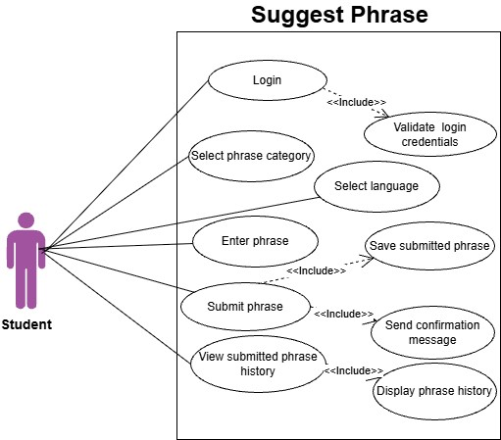
Use Case Diagrams

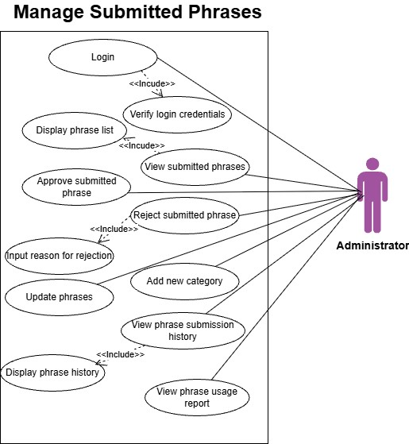
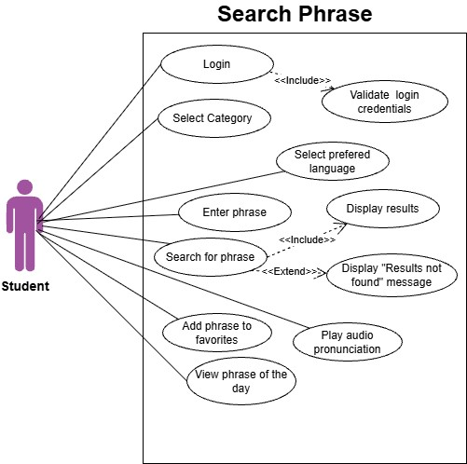

Wireframes
Home page
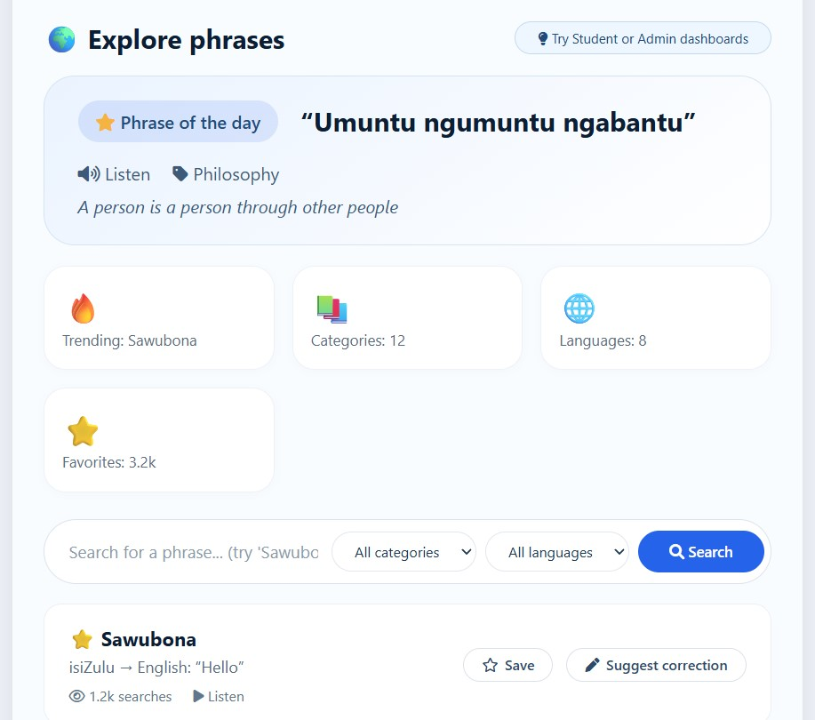
Student Dashboard
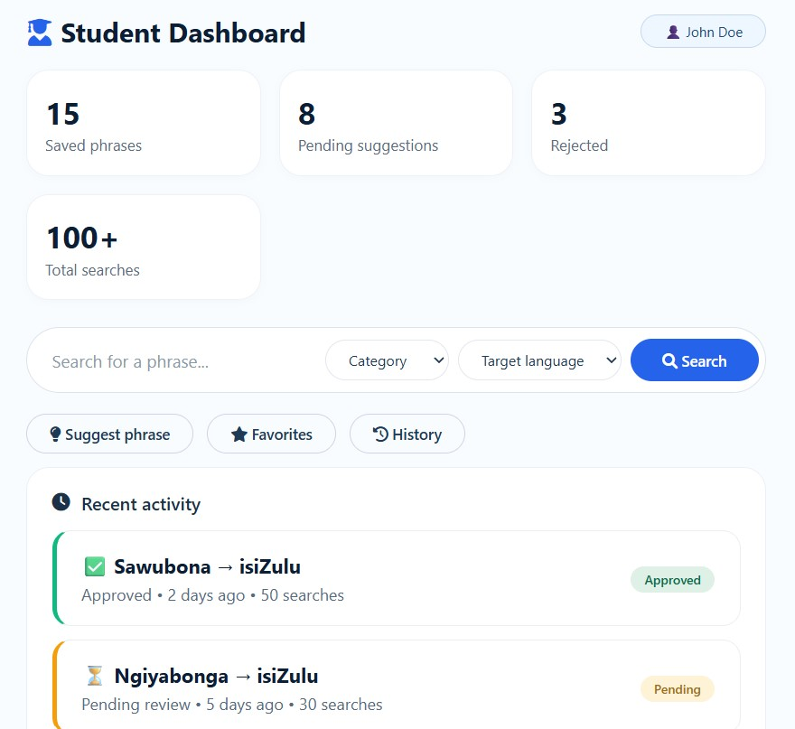
Admin Dashboard
